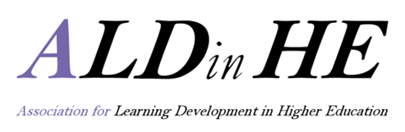

ALDinHE research funding scheme 2018
Application form
Please submit two versions of this form in your application:
- Full details version (Part I and Part 2 completed)
- Anonymised version for blind review (remove Part I and any details in text that may identify individuals and institutions)

PARTI
Research Project Lead:

Department:

Institution:

ALDinHE institutional membership: please note that ALDinHE institutional membership is a part of the eligibility criteria. In the case of collaborative projects, the research project lead has an ALDinHE institutional membership. The list of all ALDinHE institutional members, or how to apply, is available here

Does the project lead hold ALDinHE institutional membership? | YES No
Contact address:

Email:

Telephone:

Collaborative partner(s): names and affiliations

PART II
Project title:
Project start date:
Project completion date:
(Projects must be completed by 20 December 2019)

Funding amount requested: £

Project Budget outline and justification. Please provide a detailed breakdown of the costs. See the guidance document for details of what can, and cannot be funded

Proposal abstract (max. 250 words):

Full proposal (max. 1000 words, excluding references) - please make sure it addresses the application criteria outlined in the accompanying guidance document

Please return both the full and the anonymised versions of the application to research@aldinhe.ac.uk by 12 noon on 27 August 2018. Final outcomes of the review process will be announced by 30 September 2018

Please note that we will not consider applications from individuals or project teams who have been funded in the previous year.

