Students as Co-Creators DRC Project Evaluation Guidelines
As you approach the end of your research project. You are expected to reflect on your findings, evaluate the research process, and think about the impact of your research. These guidelines have been created to help you write your final report.

Your report should consist of the following sections:
- Executive Summary
- Background and Aims
- Methods
- Results
- Discussion
- Conclusion
- Lessons Learned
- Research Group Reflection

Only one report needs to be produced per team. All members of the team should contribute towards writing this report.

Section 1. Abstract (300-400 words)
A summary of your project including what you did, why you did it, and what the outcome was (based on your results).

The Antibiotics Undersea project has been a students as co-creators project to investigate the potential for marine bacteria isolated from UK coastal sediments to produce antibiotics to Vibrio parahaemolyticus a Gram-negative bacterium that is the leading bacteriological cause for illness associated with the consumption or manhandling of seafood products. This species is documented as having resistance to multiple antibiotics and is a growing and global public health threat, so there is a need to find novel antibacterial compounds that target this species. An additional part of the project was to increase awareness of the global rise in antibiotic resistance by using outreach to schools and the general public. To investigate the antibacterial compounds that may be produced by marine bacteria against Vibrio parahaemolyticus, six marine bacteria cultures were chosen according to either their demonstrated antagonist effect to V. parahaemolyticus in our previous project ‘Antibiotics Unearthed’ or their novel colony morphology in comparison to other bacteria in our culture collection. The chosen cultures were re-isolated and grown in liquid culture to the stationary phase of growth, where the crude broth was removed and used in a disc diffusion assay against V. parahaemolyticus. The results have shown that using the methods we adopted, none of the chosen cultures produced antimicrobial compounds against V. parahaemolyticus. Limitations to the methods used focus on the fact that these are bacteria isolated from environmental samples, their optimal conditions for growth are currently unknown and we are unsure whether changing growth conditions or growth phase may yield potential antibacterial compounds or perhaps whether the presence of V. parahaemolyticus in an antagonistic approach may be required for antibiotic production to this species. In addition, the crude broth was used for the disc diffusion assay and it may be necessary to concentrate the samples, considering production of compounds by the marine bacteria may be at a low concentration. This is the first time that these particular marine bacteria have been brought into liquid culture and we have provided the first reported colony descriptions for these cultures. There is also the possibility that the marine bacteria in this study may produce compounds that inhibit the growth of different pathogenic bacteria other than V. parahaemolyticus. We will build on our findings to continue further investigations on these marine bacteria, and continue to screen other marine bacteria in our culture collection in the future.

Tip: it might be a good idea to write this section last, although it needs to be at the beginning of your report.

Section 2. Background and Aims (200-300 words)
Background:
For this students as co-creators project we decided to target the bacteria species Vibrio parahaemolyticus which is the leading bacteriological cause of illness associated with seafood consumption of which there has been a global expansion of reported cases over the last two decades ( see Martinez-Urtaza et al., 2018). In addition there is emerging evidence that suggests this species can survive on plastic waste in the oceans and may contribute to the death of coral (Kirstein et al., 2016) .Of particular concern is that many reports of V. parahaemolyticus indicate multiple antibiotic resistance for this species; with resistance mainly being attributed to misuse of antibiotics to control infections in aquaculture production (Elmahdi et al., 2016).
This project builds on the previous work of our 2017-18 Antibiotics Unearthed project in which we generated a collection of 40 marine bacteria cultures from marine coastal sediments around the UK. Marine bacteria have been found to be a resource for novel metabolites and it has been documented that they can produce small molecules that exert antagonistic effects against other marine organisms (see review by Weitz et al ., 2013) although the potential for their use in biodiscovery has been severely limited by the lack of laboratory cultures (Joint et al., 2010). Since Vibrio parahaemolyticus is a species found in marine systems we anticipate that other marine bacteria may produce compounds that inhibit their growth and this has been the basis for our research.

Aims and objectives:
The aim of the project was to determine whether any of the marine bacteria from the University of Westminster marine bacteria culture collection produce compounds that will inhibit the growth of Vibrio parahaemolyticus.

To achieve this the objectives were:

- Re-isolation of all marine bacteria from the marine culture collection -to maintain the culture collection and produce ‘fresh’ cultures to work with.
- Growth of marine bacteria in liquid broth -so that cell extracts could be used for testing
- Preparation of disc diffusion assays to test the marine bacteria extracts to Vibrio parahaemolyticus- with measurement of zone of inhibition to determine any inhibition.

How do you think this research will impact YOUR learning and teaching?
Throughout the project, it was considered that many laboratory techniques would be adopted, and so the students could practice the skills already learnt during their academic year as well as learn new ones. This would help the students to be more confident in the laboratory environment and be particularly helpful when it came to the third-year research project.
As, the students were assisting the academic staff to build the project, they would be able to understand the amount of time taken for each duty scheduled. Consequently, the skill of managing the laboratory time would be useful not only for the third-year project but also for future employment.
Moreover, students from different years of study and different courses would come to know each other, so different personalities and types of knowledge would be shared during the sessions. As well, the lecturer being present during laboratory sessions would be essential for the supervision of laboratory skills and to strengthen the professional relationship between students and academic staff. Good team working as well as good time management would be required to complete the laboratory sessions.

Section 3. Methods (150-300 words)
Prior to beginning the laboratory work, ethics approval was sought and granted and a COSHH and risk assessment was completed to consider the methods and risks of working with the marine bacteria and Vibrio parahaemolyticus - a Class 2 bacteria with pathogenic potential. Risk reduction procedures were discussed, noted and executed and all work took place in Class 2 designated laboratories using appropriate procedures. A project laboratory notebook was set up for data recording, alongside a Benchling ‘online’ notebook.

Due to Linda Percy (project supervisor) being on extended sick leave during the academic year the project had to be streamlined to take into consideration time constraints and student availability. It was decided that the project would focus on marine bacteria cultures (4) that had shown some inhibition of V. parahaemolyticus in microbial antagonism experiments in the previous Antibiotics Unearthed project with 2 additional cultures chosen for analysis due to unique features to other cultures in the collection (Table 1).

Site of Origin | Culture Name | Reason for use
Port William (Scotland- West) | PW5 | Some inhibition of V.parahaemolyticus in cross-streak experiments
New Quay (Wales) | NQ7 | Some inhibition of V.parahaemolyticus in cross-streak experiments
Montrose (Scotland-East) | MY1 | Some inhibition of V.parahaemolyticus in cross-streak experiments
Holy Island (England-East) | LY1 | Some inhibition of V.parahaemolyticus in cross-streak experiments
Port William (Scotland-West) | PW6 | Distinct red pigment of colonies and floral scent
Weymouth (England-South) | B4 | Distinct orange pigment of colonies with rhizoid appearance

Table 1. Marine bacteria chosen for use in the Antibiotics Undersea - Students as co-creators project, and the reason for use.

The marine bacteria from our culture collection stored at 4 °C were checked (232 Petri dishes) and from here 49 were re-isolated by streak plating onto Difco marine agar and incubated at 18 °C. The 6 identified cultures of interest were streak plated and incubated at 26 °C for one week prior to use.
To produce liquid cultures, an individual colony from each marine bacteria culture was placed in 100 mL of sterile Difco marine broth in a 250 mL Erlenmeyer flask, vortexed briefly to distribute cells and incubated at 26 °C, 150 RPM. The following day to observe growth the optical density (OD) was measured using a spectrophotometer (600 nm). All cultures that had reached an OD of >0.600 had a volume (dependent on culture density) transferred to 100 mL of fresh marine broth to produce an OD of approx 0.100 and these flasks also incubated. The next day, a total of 6 cultures had been incubated for 48 hours, and another 5 for 24 hours, and once OD had been recorded 1.5 mL was transferred to a microcentrifuge tube and spun at 10,500g for 5 minutes. The supernatant was placed in a new tube for use in the disc diffusion assay, with the remaining cell pellet stored at -20 °C for future DNA analysis. Sterile autoclaved 6 mm diameter filter discs were loaded with 40- 100 𝞵L of culture supernatant in increments of 20 𝞵L and left to dry between loadings, with the process completed over 2 days. A negative control was prepared for each assay by loading between 40 -80 𝞵L of marine broth (no bacteria) onto a disc.
For the disc diffusion assay V. parahaemolyticus grown overnight in nutrient broth at 37 °C at a 0.5 McFarland turbidity equivalence was swabbed across Mueller Hinton agar plates. Each plate was divided into 6 and then loaded with a positive control 6 mm Tetracycline 30 𝞵g (Oxoid) antibiotic disc, a negative control disc (Difco marine broth only) and four discs loaded with 40 -100 𝞵L of the bacteria culture supernatant (Figure 1). Each plate was performed in duplicate. Samples from cultures 23-24h in growth were labelled ‘new’ and samples in culture for 48 hours were labelled ‘old’ to distinguish them from one another. The Petri dishes were viewed after 24 hours and the zone of inhibition surrounding the discs measured and recorded.

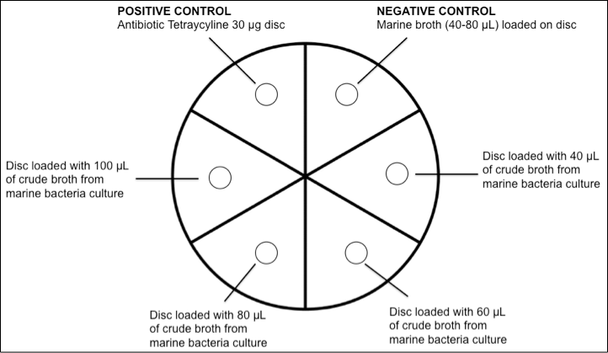

Figure 1. Method used to load discs onto Mueller Hinton agar dish swabbed with V. parahaemolyticus

Section 4. Results
Outreach
Members of the project had a stand at the ‘2019 Science4sustainability 16th Annual Schools’ conference discussing the problem of antibiotic resistance and developing new antibiotics (Fig 2). This conference was attended by over 370 students in years 9 to 11 from 19 participating schools and colleges across London. The stand generated interest and a wide range of literature relating to the topic was given to the students that attended.

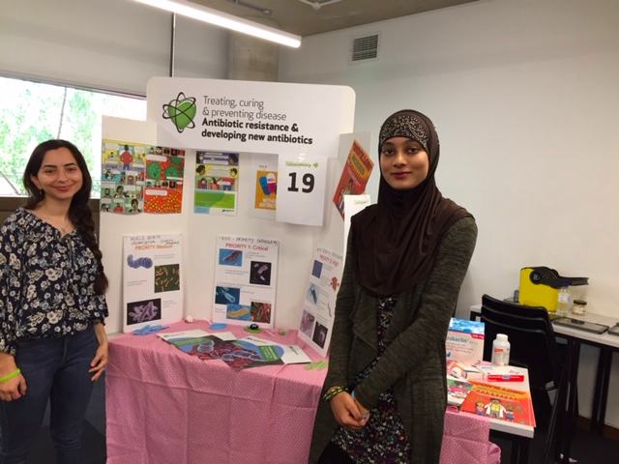
Figure 2. Sara Ahmed and Samaiya Asif on our stand at the 2019 Science4sustainability 16th Annual Schools’ conference.

We have had Twitter @Antibiotics_Sea and Instagram Antibiotics_sea accounts for the project and have been using these to promote the project along with forwarding posts on the topic of antibiotic resistance to spread the antibiotic resistance message to the general public. The posts have been followed by a range of accounts including international and based on the popularity of these posts it is evident that nowadays social media is a great channel to spark the general public's interest in important topics and can be used as a tool for involvement in the project through dissemination of the research and its results.

Laboratory findings

Colony morphology
The colony morphology varied between cultures and was documented using the different descriptors used by the National Collection of Industrial Food and Marine Bacteria (NCIMB) (Table 1) and by photomicrograph (Figure 3).

Culture | Colony Shape | Colony Size (mm) | Elevation | Margin/  Border | Surface | Opacity | Colour
Port William PW6 | Circular | 1 | Pulvinate | Entire | Smooth,  Glistening | Opaque | Pink  /Peachy
Montrose  LY | Rhizoid | 4 | Flat | Lobate | Rough, Wrinkly | Opaque | Orange  /Yellow
Weymouth B4 | Irregular  /Circular | 4 | Flat | Undulate | Smooth, Glistening | Opaque | Peachy
Montrose  MY1 | Circular | 2 | Raised | Entire/  Undulate | Smooth, Glistening | Opaque | Deep Yellow
Port William PW5 | Circular | 2  (some  <1) | Convex | Lobate or Entire | Smooth, Glistening | Opaque | Yellow
New Quay NQ7 | Irregular | 3.5 | Umbonate | Undulate | Smooth, Glistening | Opaque | Creamy

Table 1. Description of the colony morphology of the six selected cultures. The description is based on the colony size, shape, elevation, margin, surface, opacity and colour.

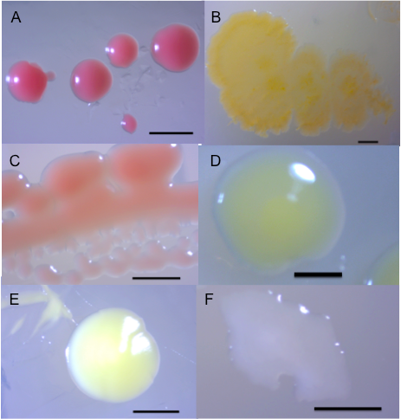
Figure 3. Photomicrographs of the marine bacteria cultures used in this project, demonstrating colony morphology when grown at 26 °C on Difco Marine agar (A) Port William PW6, (B) Montrose LY, (C) Weymouth B4, (D) Montrose MY1 (E) Port William PW5 (F) New Quay NQ6. Scale Bar = 1.0 mm

Growth of marine bacteria in Difco marine broth
All marine bacteria (except PW6) grew well in the marine broth using the incubation conditions of 26 ºC and 150 RPM, reaching an OD of >0.6 on inoculation of marine colony to broth within 24 hours, and the pigmentation seen when grown on Petri dishes remained when the culture was grown in the broth (Figure 4).

A
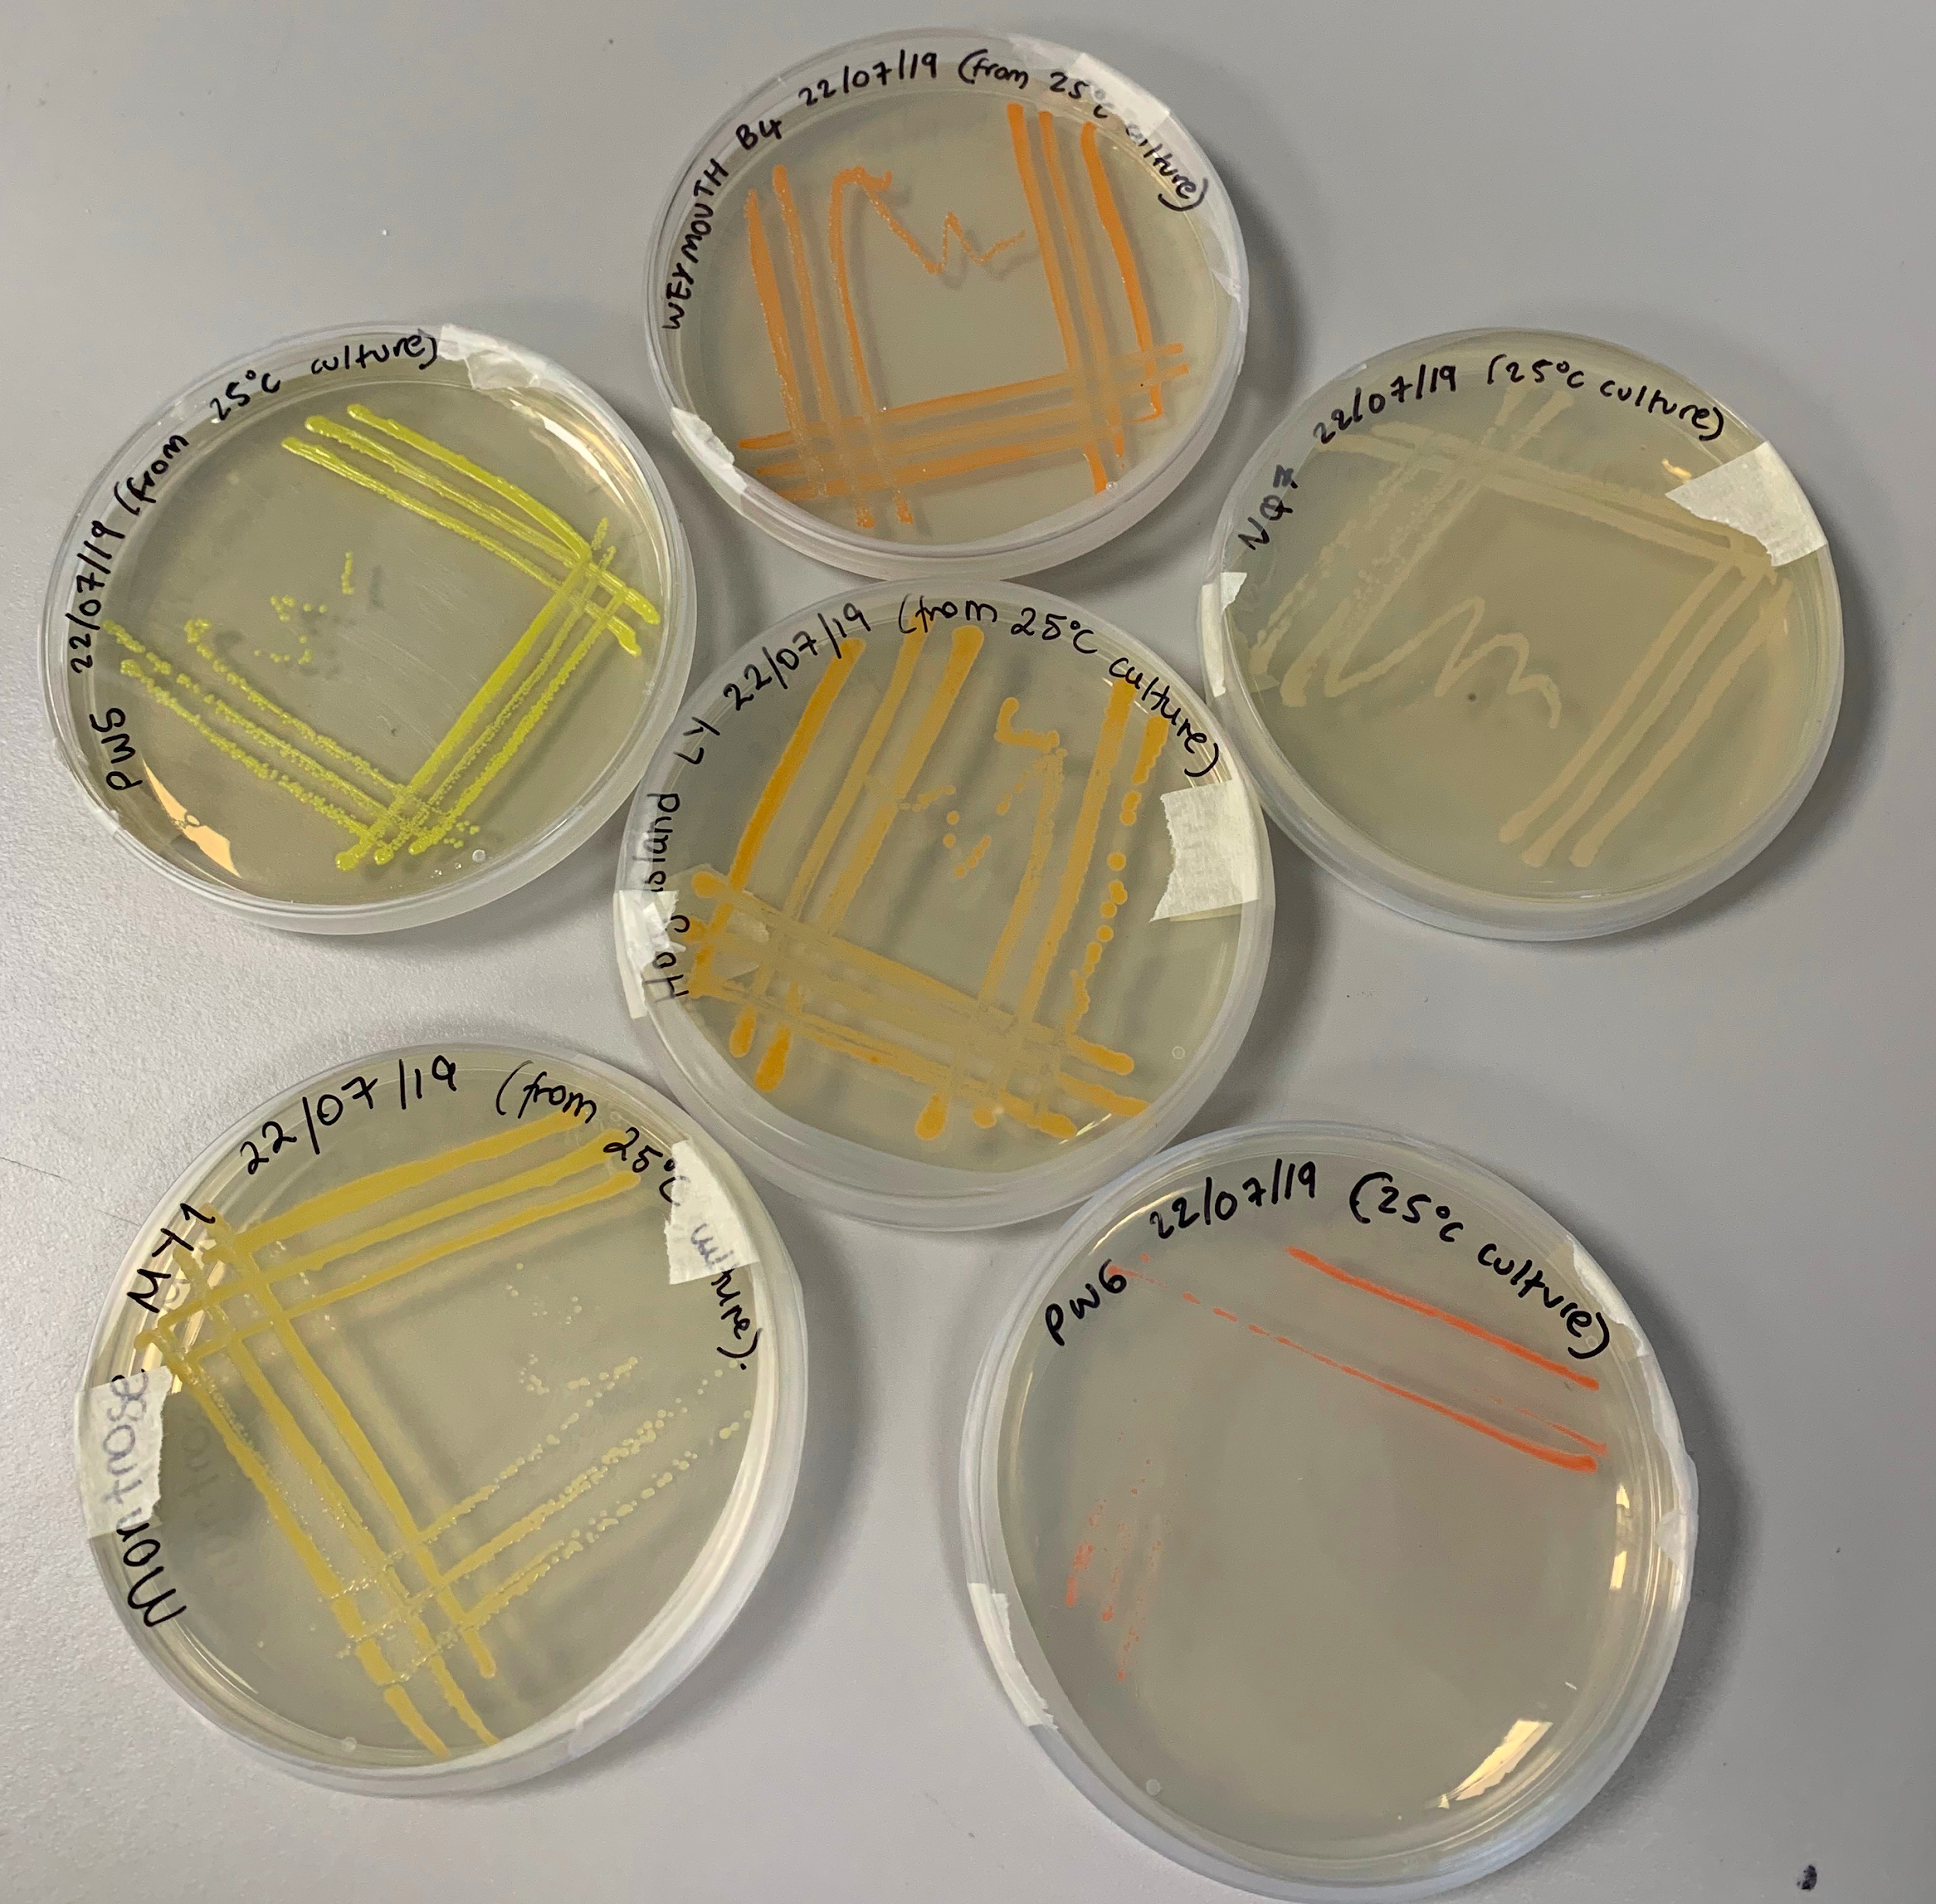
B
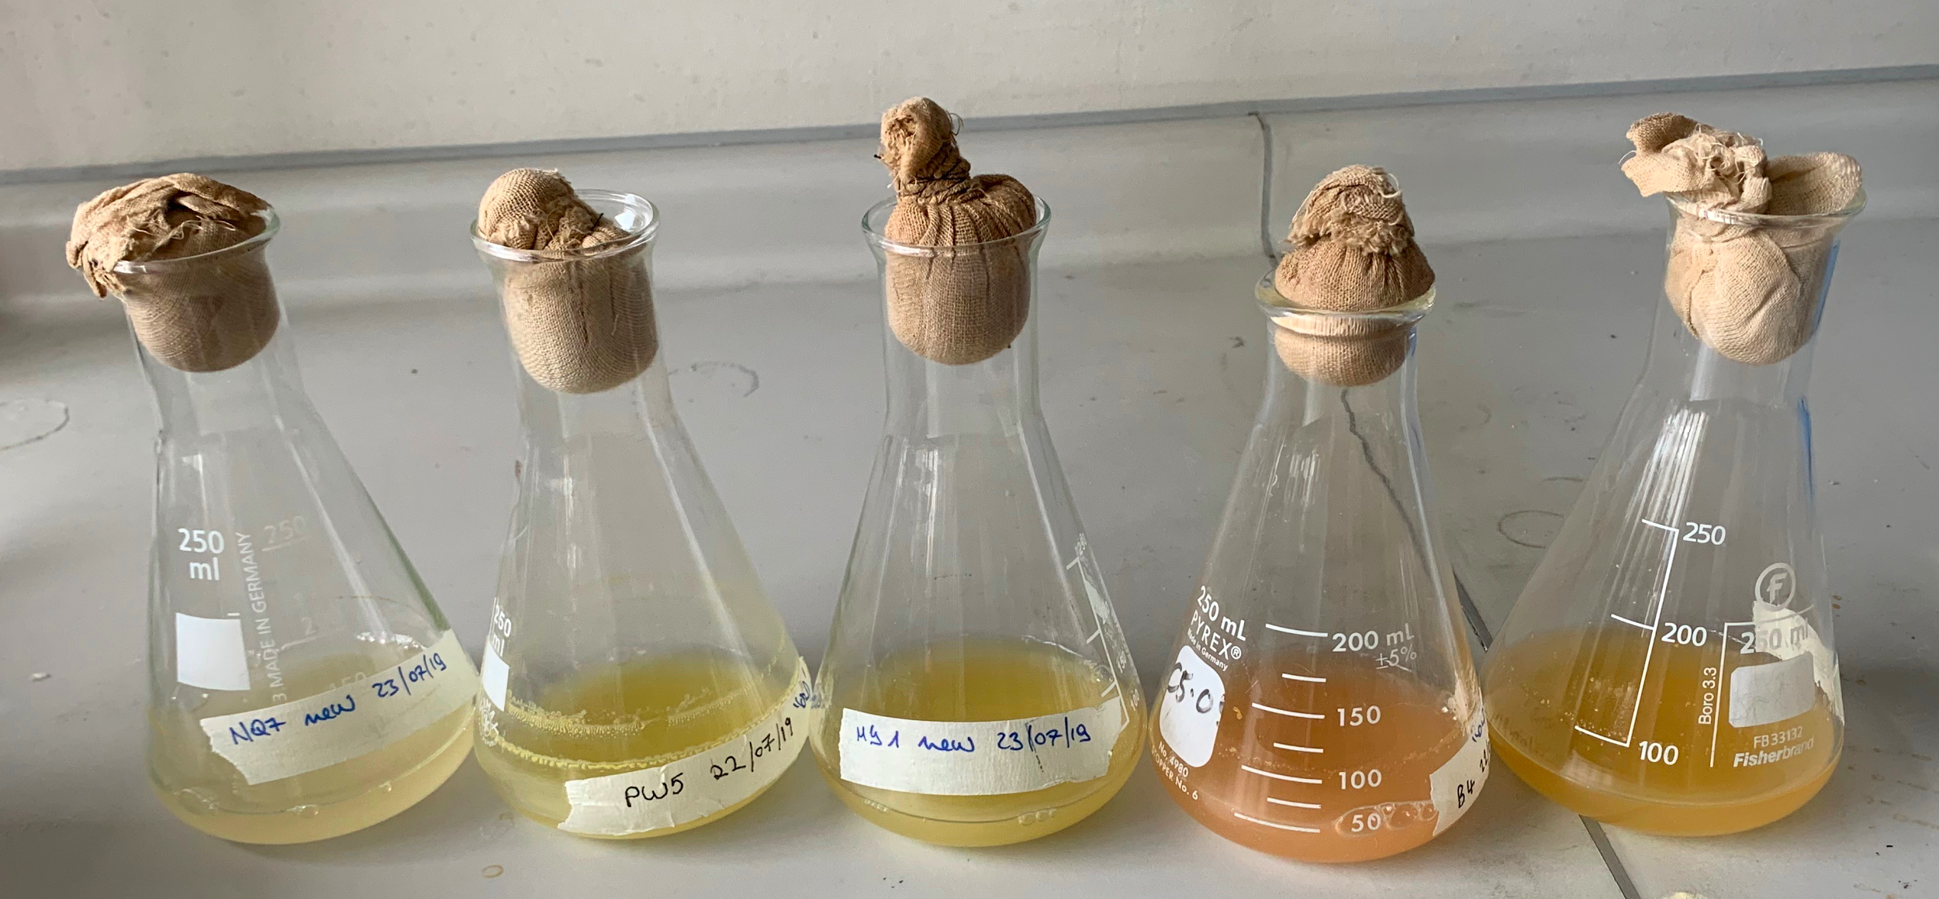
Figure 4 (A) Marine agar dishes of marine bacteria used in this experiment showing streak plate growth clockwise from top left to right PW5, B4, NQ7, PW6, MY1 and LY in the centre (B) Marine bacteria cultures growing in the marine broth showing retention of pigment when grown in broth at 26 °C and 150 RPM incubation. Left to right NQ7, PW5, MY1, B4 and LY. Culture PW6 is not shown.

Disc diffusion assay
The disc diffusion assay results indicated that the positive control (Tetracycline 30 𝞵g) worked for each of the plates, producing a zone of inhibition of 25-29 mm and the negative control of the marine broth resulted in no inhibition of V. parahaemolyticus, indicating that the marine broth does not inhibit growth ( see example in Figure 4). No entire zone of inhibition was found from any of the discs loaded with the crude marine bacteria broths (Table 3) although for the NQ7 ‘new’ sample there was a small region near the discs loaded with 40 𝞵L where the V. parahaemolyticus seems not to have grown, although discs loaded with higher volumes showed no inhibition, and so this may be an artefact of the way the V. parahaemolyticus was swabbed on the plate with growth not being confluent (Figure 5).

 | Disc/Sample loaded on disc and measured zone of inhibition (mm)
Culture Name | Positive control Tet (30 𝞵g) | Negative control (marine broth) | 40 𝞵L | 60 𝞵L | 80 𝞵L | 100 𝞵L
PW6-old (1) | 25 | None | None | None | None | None
PW6-old (2) | 25 | None | None | None | None | None
PW5-new (1) | 25 | None | None | None | None | None
PW5-new (2) | 26 | None | None | None | None | None
PW5-old (1) | 26 | None | None | None | None | None
PW5-old (2) | 25 | None | None | None | None | None
LY -new (1) | 26 | None | None | None | None | None
LY-new (2) | This plate did not work -no growth of V. parahaemolyticus
LY -old (1) | 26 | None | None | None | None | None
LY -old (2) | 24 | None | None | None | None | None
MY1- new (1) | 25 | None | None | None | None | None
MY1- new (2) | 25 | None | None | None | None | None
MY1- old (1) | 26 | None | None | None | None | None
MY1- old (2) | 25 | None | None | None | None | None
B4- new (1) | 26 | None | None | None | None | None
B4- new (2) | 28 | None | None | None | None | None
B4- old (1) | 29 | None | None | None | None | None
B4- old (2) | 26 | None | None | None | None | None
NQ7- new (1) | 28 | None | * | None | None | None
NQ7- new (2) | 28 | None | * | None | None | None
NQ7- old (1) | 27 | None | None | None | None | None
NQ7- old (2) | 28 | None | None | None | None | None

Table 2. Results of the disc diffusion assay with 40-100 𝞵L of marine bacteria crude broth loaded onto 6 mm sterile discs using Tetracycline 30 𝞵g as a positive control and marine broth as a negative control.

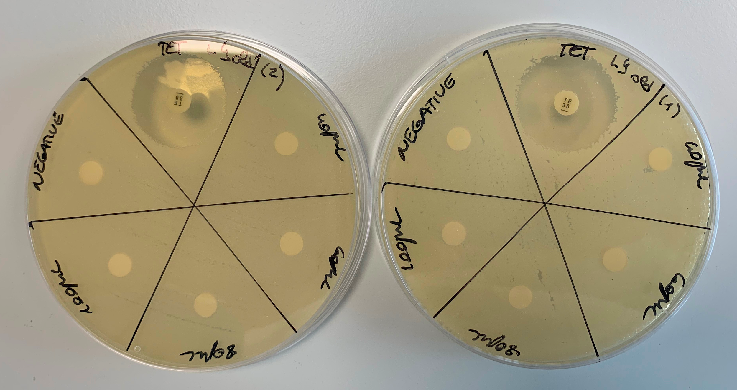
Figure 5 Example of the disc diffusion assay results. This is for LY1 ‘old’ that has been plated in duplicate. The confluent growth of Vibrio parahaemolyticus can be seen throughout each plate with a clear zone of inhibition around the Tetracycline antibiotic discs. There is no zone of inhibition around the negative control (marine broth only) or the discs loaded with 40-100 𝞵L of the LY bacteria supernatant.

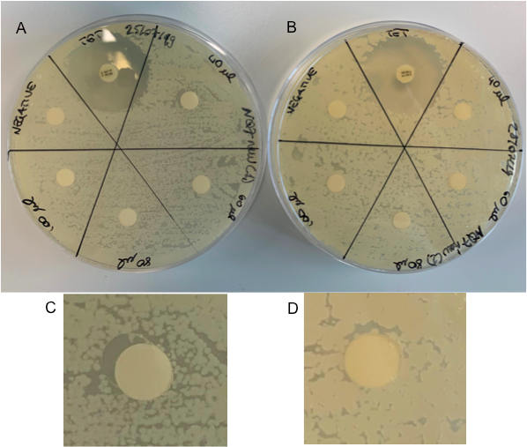

Figure 6. Disc diffusion assay results for culture NQ7 ‘new’ (A) is the first assay plate in entirety and (C) shows the disc loaded with 40 𝞵L of culture supernatant indicating a possible small amount of inhibition around part of the disc. (B) is the duplicate assay plate with (D) being the 40 𝞵L disc for this plate, also with small area where the V. parahaemolyticus seems not to have grown.

When writing this section, look at your results, graphs and tables and ask yourself – what does this data mean?

Section 5. Discussion (300-600 words)
The marine bacteria used in this experiment were successfully brought into the liquid culture for the first time, and all were found to maintain their pigment in the liquid broth which is a good outcome as marine bacteria with unique colour properties have been found to have broad-ranging pharmacological activities (Soliev et al., 2011). Culture PW6 did not reach the OD of the other cultures, although this may be because the colonies of this culture were generally much smaller (some <1mm) than those of the other cultures as documented by the colony photomicrographs, which were the first images that we have captured of these colonies.
The disc diffusion assay results indicated that the Tetracycline (30 𝞵g) is a suitable positive control to use in an assay with Vibrio parahaemolyticus as a consistent clear zone of inhibition was seen for each plate. In addition, the negative control indicated that the Difco marine broth did not inhibit the Vibrio parahaemolyticus when discs were loaded with up to 80 𝞵L of broth, which would allow us to therefore be confident that any inhibition from marine bacteria culture would be from cell exudate rather than the marine broth. Our experiments confirmed that there was no zone of inhibition produced by the marine bacteria cultures tested. Although this may be because the cultures did not produce an antibacterial to V. parahaemolyticus we have also determined that there are a number of limitations to the experimental methods used for this project. The marine bacteria were isolated from UK environmental coastal sediment samples, and UK sea temperatures would generally be at a temperature of no higher than 20 °C, with Scottish sites experiencing a lower maxima. As such, at the 26 °C, used in these experiments, the bacteria may not produce antimicrobial compounds, although they may do at lower temperatures. In addition, the need for another bacteria’s presence may be required for the production of the antibiotic, for example in the natural environment the marine bacteria would be in an assemblage with others and for a compound to be produced by antagonism, the marine bacteria would need to be exposed to other bacterium. This may be the reason some inhibition was seen during the Antibiotics Unearthed project as marine bacteria were in close contact in cross-streaking experiments with V. parahaemolyticus, which was not the case in this project, and is more difficult to achieve when growing in liquid culture. There may also be some ingredient lacking within the type of broth used and there may be a possibility that the bacteria produce the compounds in a different stage of growth phase rather than at the stationary phase, at which we took the samples. Since we currently do not know the species identification of all the marine bacteria used in this project, once the molecular analysis of the pellets stored from this project has been completed, we may be able to perform more targeted growth experiments. There is also a limitation of using the crude broth for a disc diffusion assay, as it may be that cells are producing a compound of interest at very low concentrations, as we did not try to perform solvent extractions to concentrate the sample. There are also limitations to using a disc diffusion assay as the rate of dispersion of compounds through the agar may be variable. It may also be possible that the marine bacteria tested do not produce antimicrobial compounds against V. parahaemolyticus although they may be effective against another species of bacteria not tested within this project. Since there are so many variables and potential limitations to these experimental approaches, an alternative approach would be to produce whole genome sequences of the marine bacteria species and then search these for potential genes of interest using bioprospecting approaches (eg Zotchev, Sekurova and Katz, 2012), which may also provide information on other natural therapeutic compounds of interest.
Tip: When writing this section think about your aims. Did you achieve your aims? Were your results as expected? Are you findings consistent with other work in the literature?

Section 6. Conclusions and Future Work (200-300 words)
This section should include: key messages/findings as well as suggestions for how your work could be continued in the future.

This students as co-creators project has allowed us to investigate the potential for six marine bacteria cultures to produce antibacterial compounds to the pathogenic bacterium V. parahaemolyticus. On growing the marine bacteria in Difco marine broth at 26 °C, 150 RPM disc diffusion assays indicated that when using 40 -100 𝞵L of the crude broth no inhibition of V. parahaemolyticus was found. It may be possible that the marine bacteria need to be in the presence of V. parahaemolyticus to produce an antibacterial due to an antagonism reaction, or that adapting the growth conditions or concentrating the extracts rather than use a crude broth extract may yield an inhibitory result. These are all experimental approaches that could be used for future research. All the marine bacteria liquid cultures were found to retain pigmentation and it may well be that the biopigments produced by these bacteria may have other potential uses and that also bioprospecting using molecular methods of whole genome analysis rather than employing many different growth variables may be a more suitable alternative to use. The global rise of antibiotic resistance is an important topic and we have helped to spread the message of this topic through our stand at the Science4sustainability schools event and through the use of social media platforms.

Section 7. Lessons Learned (200-600 words)
New microbiological techniques were employed that will be helpful during the new academic year(s) practices. As students we have gained confidence in the laboratory, which we consider will help us to be more active in academic group sessions and to have a better performance. We also gained confidence in trying new techniques and discovering their outcomes. Additionally, as students we learnt from each other as some had acquired skills in techniques through the academic years or through different courses (we had members of the team from different pathways and at different course levels). We learnt that team working and good communication were essential for the preparation and the division of the duties during the lab sessions. Another lesson was taught by the project itself and it is a life-long lesson, as not always do you have the results expected and that things not initially planned can also influence the outcomes. Also, in research the time taken can be longer than first planned and still not result in having any particular expected findings. However, the project has also taught us that this time is not completely wasted, as negative results are also considered results and scientists can research further based on them. An example is how the Antibiotics Undersea co-creators project was based on the Antibiotics Unearthed project results. In the Antibiotics Unearthed project we had spent many hours isolating cells to produce bacteria cultures, but not had the opportunity to take them to the next stage of disc diffusion assays test, so it was good to see how this work was progressing with our cultures and to consider how our co-creators project can be taken further by beginning to address the limitations in methods and use of environmental samples that we have highlighted from our research.
Tip: Think about how you are going to get your research across to your stakeholders. Be realistic about this and consider whose help you may need in the process.

Section 8. Group Reflection (200-300 words)
The success of the project was probably due to the effort, the ideas and the work brought by the teachers (note: this is a student comment) as well as having a number of students who were committed to carry out the project. The main problem in this research was the variety of the colonies and the possible methods that could be used during the experiment as it was difficult to choose a route to start with and we have reflected on this in the discussion of the limitations of the experimental approach.
Initially the project was designed for a larger group with the main co-creators facilitating each group, however since L.Percy was on sick leave we were unable to do this, and we therefore had to use a more stream-lined approach to our research. With larger group sizes we could perhaps have screened many more cultures from our culture collection, although we did focus on those that had yielded some inhibition of V. parahaemolyticus from the Antibiotics Unearthed project, and these did not produce any inhibition in our experiments.
Collaborative working has been a great asset to carry out the experiments as the majority of the questions and problems were solved with teamwork by discussing what could have been done. We used a WhatsApp group chat to discuss the project and organise the days when different members would be available to carry out the experiments, as daily laboratory attendance was required for the growth and disc diffusion assay experiments. In addition, all experimental procedures were documented in the group laboratory notebook and the online Benchling notebook was also used, which can be quite difficult to navigate at times, and so we therefore had a paper notebook in the lab and an online notebook to share what had been done.
The problems that have occurred were mainly due to the limitations of the experimental procedures and the fact that we have been working with environmental samples that we have no previous knowledge of, so each new piece of information we find out about them is a new discovery. Within our project we have considered limitations of the methods used and have suggested different strategies and methods that could be used for future work.
References

Elmahdi, S., DaSilva, L.V and Parveen, S. (2016). Antibiotic resistance of Vibrio parahaemolyticus and Vibrio vulnificus in various countries: A review. Food Microbiology. Vol 57:128-134. Available at: https://www.sciencedirect.com/science/article/pii/S0740002016000228

Joint, I.Mühling, M. and Querellou, J. (2010), Culturing marine bacteria – an essential prerequisite for biodiscovery. Microbial Biotechnology, Vol 3: 564-575. Available at:https://onlinelibrary.wiley.com/doi/full/10.1111/j.1751-7915.2010.00188.x

Kirsteina, I.V., Kirmizia, S., Wichelsa, A., Garin-Fernandeza, A., Erlera, R., Löder, M., and Gerdtsa, G. (2016). Dangerous hitchhikers? Evidence for potentially pathogenic Vibrio spp. on microplastic particles (2016). Marine Environmental Research Vol 120: 1-8. Available at: https://www.sciencedirect.com/science/article/pii/S014111361630112X?via%3Dihub

Guillen, J., Natale, F., Carvalho, N., Casey, J., Hofherr, J., Druon, J., Fiore, G., Gibin, M., Zanzi, A., and Martinsohn, J.T (2018). Global seafood consumption footprint. Ambio (2018). Pages 1-12. Available at: https://link.springer.com/article/10.1007/s13280-018-1060-9

Martinez-Urtaza J, Trinanes J, Abanto M, Lozano-Leon A, Llovo-Taboada J, Garcia-Campello M. (2018). Epidemic Dynamics of Vibrio parahaemolyticus Illness in a Hotspot of Disease Emergence, Galicia, Spain. Emerg Infect Dis.Vol 24(5):852-859. Available at: https://dx.doi.org/10.3201/eid2405.171700

Soliev, A.B. Hosokawa,K. and Enomoto, K. (2011). Bioactive Pigments from Marine Bacteria: Applications and Physiological Roles. Evidence-Based Complementary and Alternative Medicine.Vol. 2011, Article ID 670349, 17 pages. Available at:https://doi.org/10.1155/2011/670349.

Wietz, Matthias & Duncan, Katherine & Patin, Nastassia & Jensen, Paul. (2013). Antagonistic Interactions Mediated by Marine Bacteria: The Role of Small Molecules. Journal of Chemical Ecology. Vol 9. 879–891. Available at: https://doi.org/10.1007/s10886-013-0316-x

Zotchev, S.B. Sekurova, O.N., Katz,L. (2012) Genome-based bioprospecting of microbes for new therapeutics. Current Opinion in Biotechnology. Vol 23, Issue 6, 2012, Pages 941-947.Available at: https://www.sciencedirect.com/science/article/pii/S095816691200064X?via%3Dihub

Submission Instructions:
Please attach the cover sheet to the front of your report and email the report to studentpartnership@westminster.ac.uk by the 24th July 2019.

